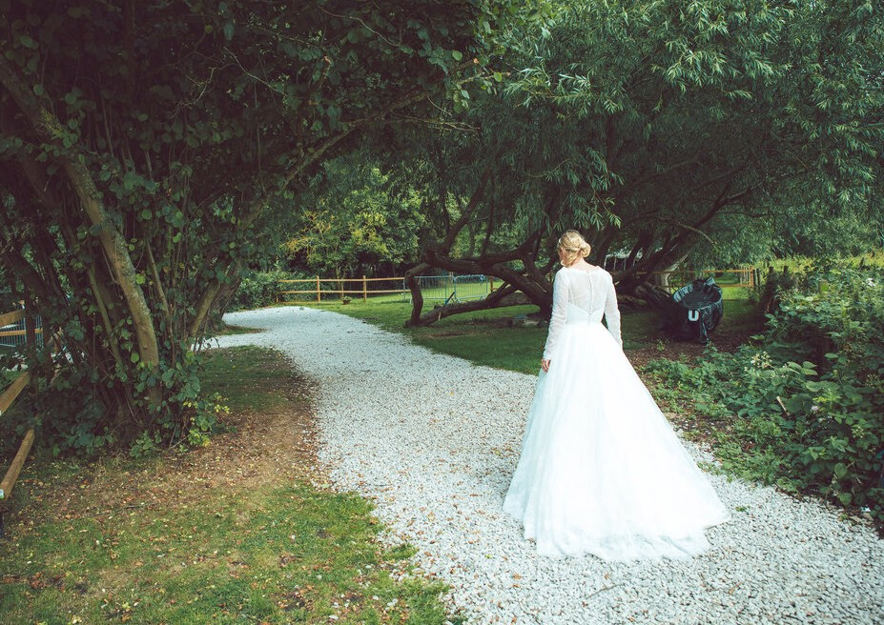
WEDDINGS AT
THE ISIS FARMHOUSE
Gorgeous, unspoiled, characterful riverside venue

THE ISIS FARMHOUSE 2024/2025

ESSENTIAL INFORMATION
Set on the banks of the River Thames, The Isis Farmhouse offers a unique, rustic
setting for your celebrations.
Two unique venue options offering river views, extensive meadows and sweeping willows providing a one-of-a-kind backdrop. With boat arrivals, hog roasts, feasting menus, garden
games and fire pits, you have everything you need to ensure stylish and relaxed festivities.

Beautiful riverside & meadowside setting
Total capacity, including evening guests 450
Small weddings available for 25-60 people
Meadowside stage for private ceremony (services include: civil, humanist, blessing)

Late license until 12am (Friday and Saturday)

All Prices below are exclusive of VAT at 20%

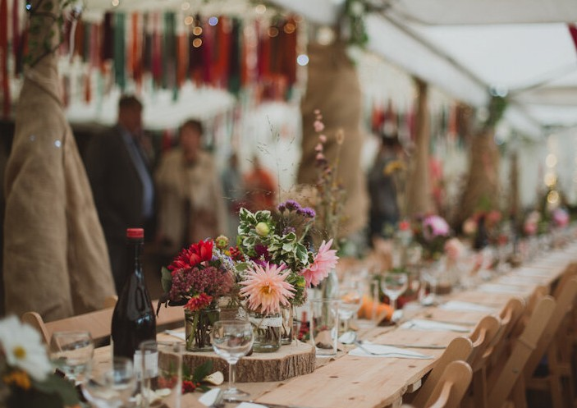
THE BARN, MEADOWSIDE MARQUEE & PARKLAND

Set in two acres of private meadowside parkland.

Seating for 80 to 350 people in the marquee
+ a further 70 people in the attached barn
Private riverside meadow entrance with mooring if you wanted to arrive by boat.
Private bar with local and international beers, lagers and ales on tap with a selection of wines, spirits and cocktails
Indoor stage & PA System
Lighting system, air conditioning & heating
Fairy lights Trestle tables & chairs
Outside grounds with option of fire pit & lawn games

HIRE
£950 Mon–Thurs
£2250 Friday & Sunday
£2750 Saturday
Prices are exclusive of VAT at 20%

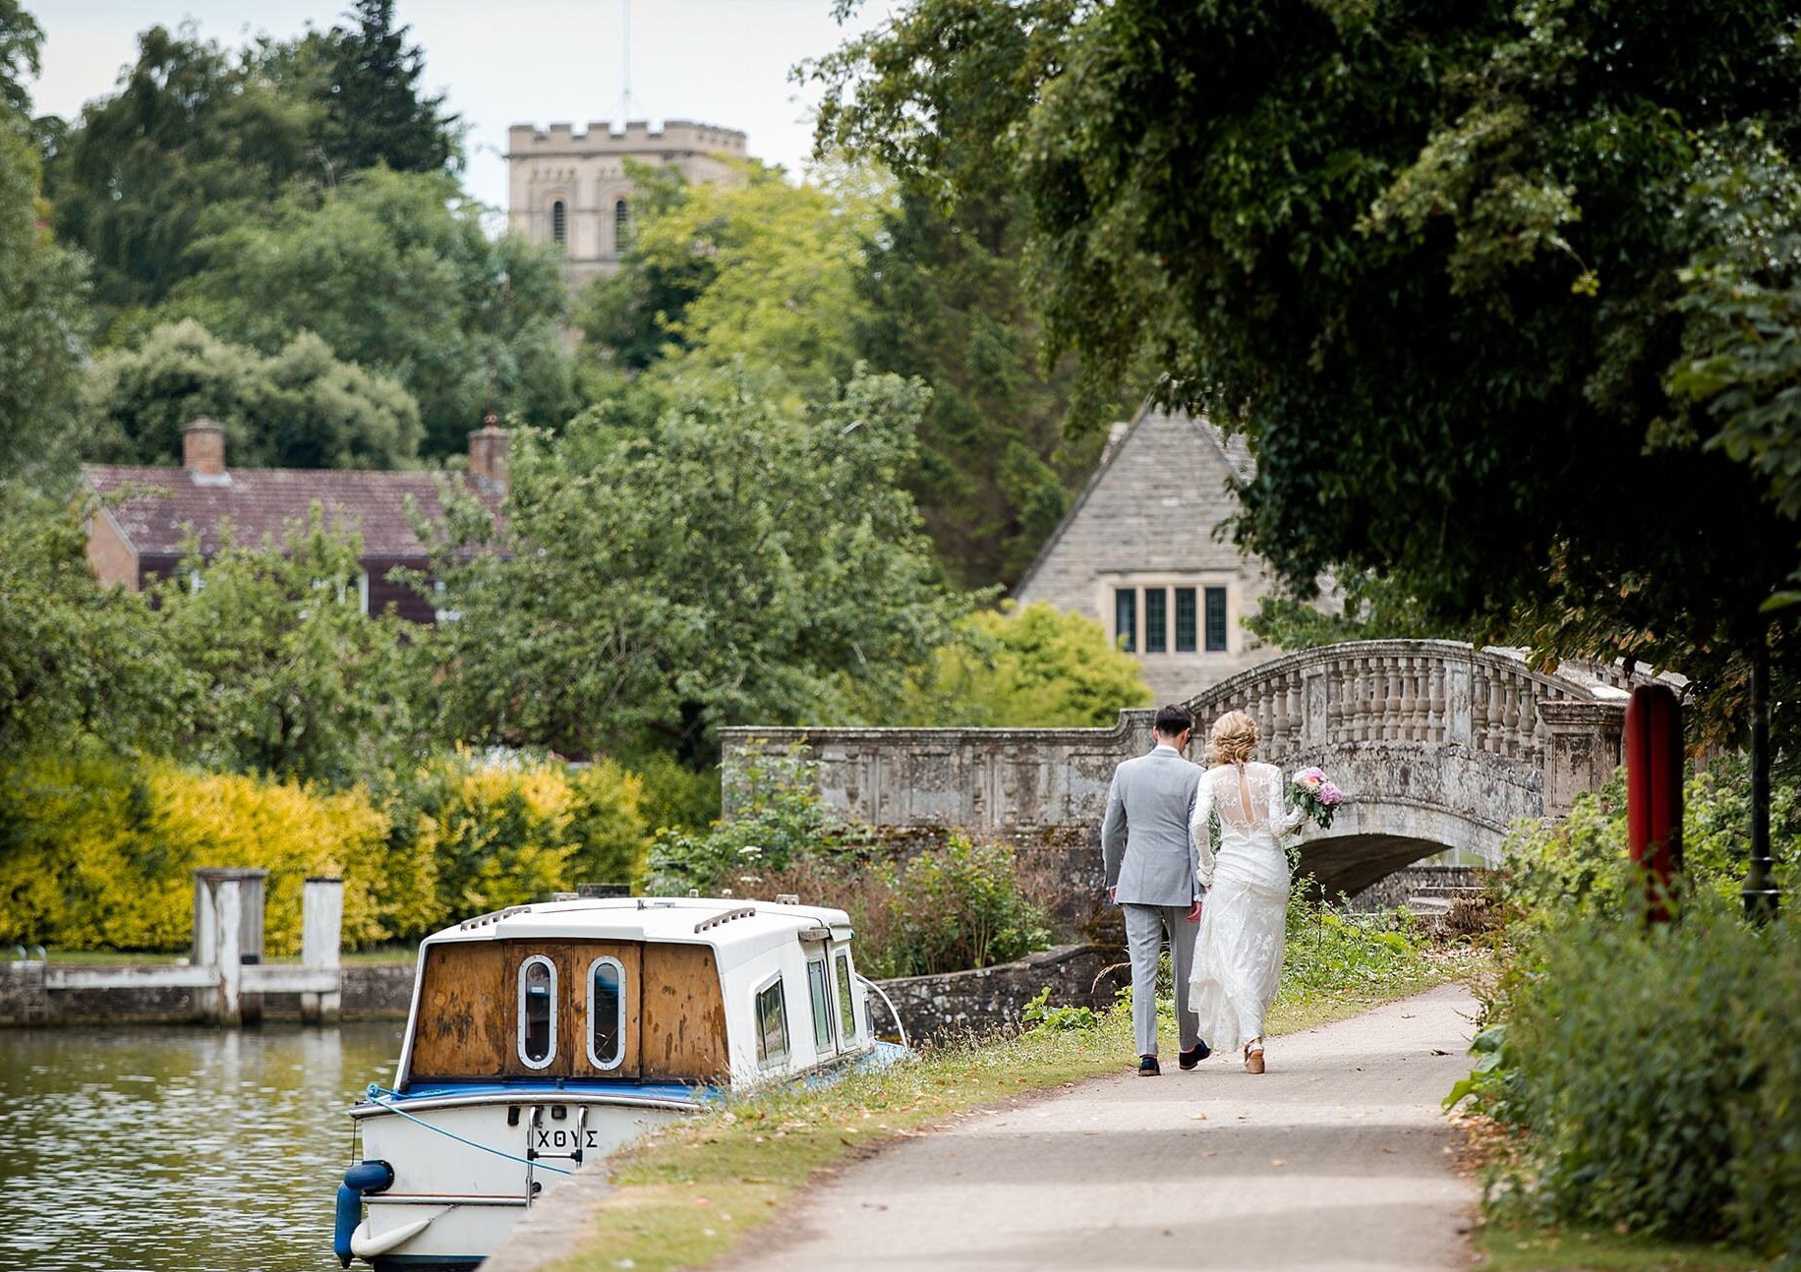
THE RIVERSIDE MARQUEE & GARDENS

Magical, fairy-lit marquee with riverside views & private gardens overlooking the river and nature reserve and leading to the Georgian music room
Available with seating from 20 to 150 people
Scenic riverside entrance with mooring if you wanted to arrive by boat.
Double doors leading into the Georgian Music Room with stage, for bands/DJ’s full
P.A. System and dance floor.
Fairy lights, rustic elegant furniture, gothic fireplace with log burner and chandeliers.

A large private bar with l with full selection of wines, beers, spirits, cocktails.
Riverside garden plus a private meadowside courtyard garden area with option of fire pit & seating

HIRE

£950 Mon–Thurs
£1450 Friday & Sunday
£1950 Saturday
Prices are exclusive of VAT at 20%

DECORATIONS, GAMES

& EXTRAS
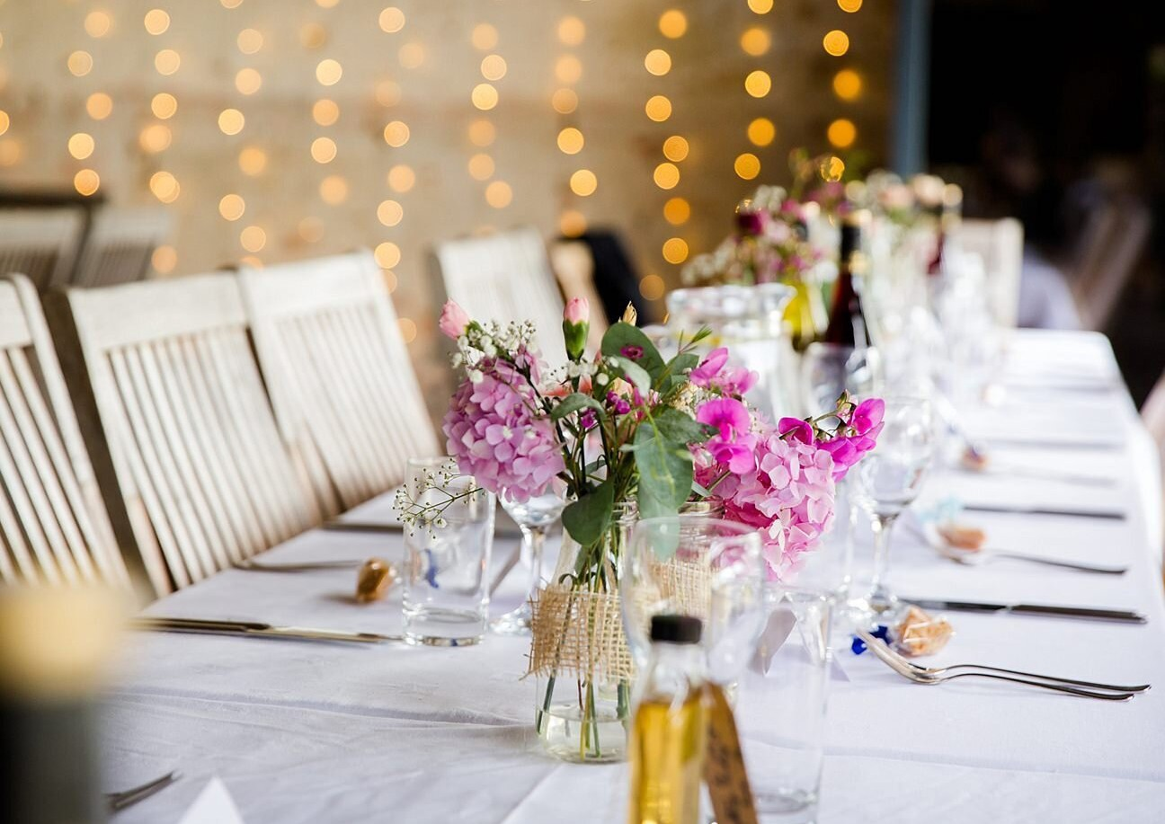

Wedding cover charge of £7.50 per person is applicable & includes: -
- Complimentary table and room decoration including fairy lights, candles, napkins, decorative easel for table plan, A-boards for signage, candelabras, flower vases and jars, leather sofas, iron love seats, wedding thrones, rustic cart for drinks, wedding cake or guest book/gifts. (Guests can of course bring any additional decoration or we can provide all/any of the above).
        - Full P.A. system for bands/DJs/speeches and use of projector or large screen.
        - A dedicated music co-ordinator to manage your music throughout the day who will liaise with, and help set up bands/musicians,
and provide background music or playlist for dancing with music of your choice or manage your own playlist.
- Assistance with venue decoration, deliveries, providing trolleys and storage.
- Liaising with any outsourced companies (bands, DJs, florists, etc.). Full cleaning service.
- Complimentary cutting of your wedding cake and served with evening food.

A selection of garden games are also available including:-
Aunt Sally, Crazy Croquet, Giant Jenga, Boules, (£75)

Extensive garden package includes all of the above plus:
8 x Adult & Children Sumo wrestling suits and mats, Tug of war, Football with goal net, Full-size pool table,
Badminton table. Basketball & hoop, Tiny-tots fun corner. (£145)

3-channel Silent Disco (£2 per headphone). Fire pit with wood and seating (£75)

Meadowside Wedding ceremony with rustic chairs, stage, Pagoda, amplifier, microphone. £2.50 per person.

Daytime or ceremony musicians and evening bands. (Please ask for details)

Table linen can be hired £5 per cloth.

Self-Catering & Corkage: We are unable to offer this service due to access restrictions for outside caterers.

SERVICE CHARGE
A discretionary 7.5% service charge will be added to your final bill. This is shared between the wedding team who have worked on all aspects of your event.

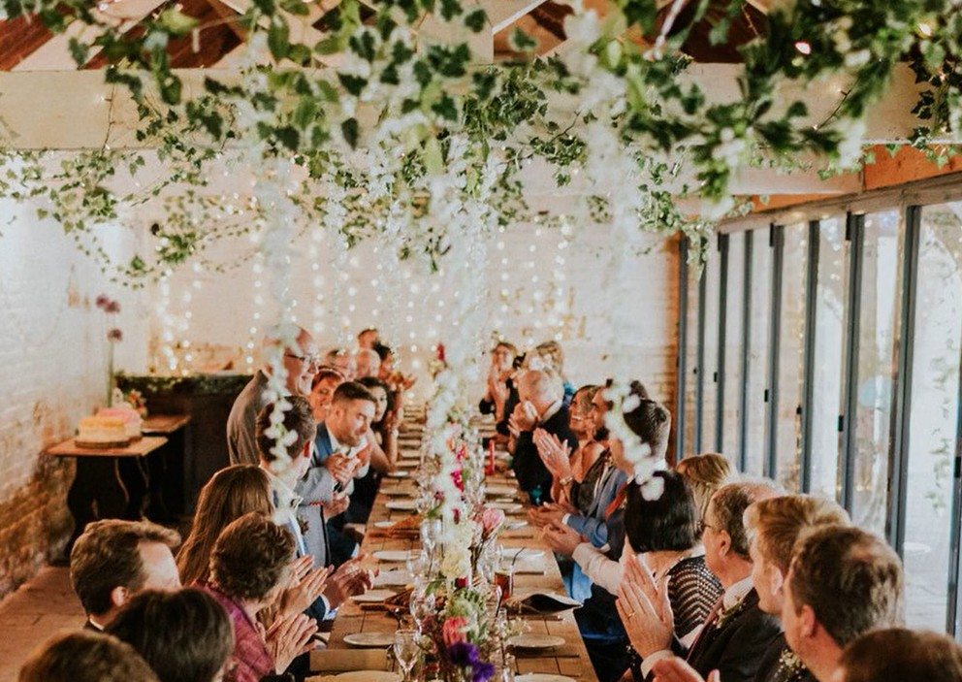

DINING & DRINKING

Range of menus available from £29.50 per person plus vat.

From fabulous hog roasts to 3-course feasting menus, you are welcome to select a style of food that suits you best.
Canapés can be served on arrival, with simple evening nibbles stunning cheese towers or hearty options to keep the party going until late.
Drinks & wine list available separately.

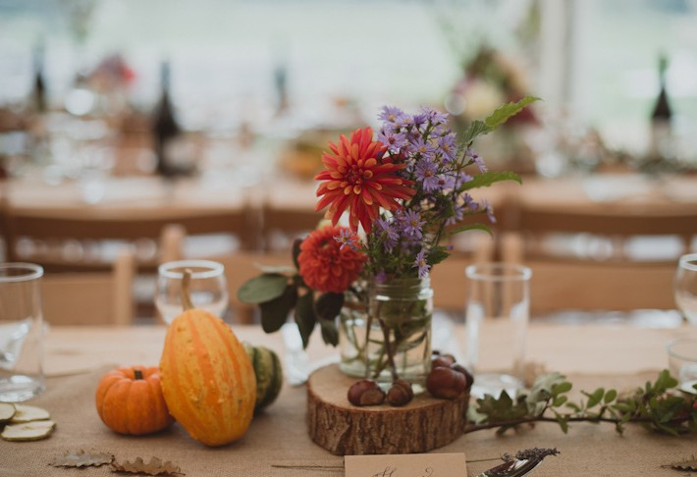
MENUS

Menu Options
(We can adapt menus to provide vegetarian or vegan only selection). We are able to provide many of the dishes gluten free, please ask for details.
Canapés £2.75 each
We serve a mixed selection of the following & recommend allowing for approximately three to four per person.
- Mandarin & Prune with Smoked Duck on White Bread.  - Trout Roe, Smoked Trout & Cucumber on Black Bread.  - Ham & Fig Butter on Olive Bread.  - Prawn, Basil-flavoured Cheese & Tomato Mini Brioche.  - Smoked Salmon, Lemon-flavoured Cheese & Cucumber Mini Brioche. | Vegetarian  - Aubergine, Ewe’s Cheese & Almonds on toast with Fig & Hazelnuts.  - Horseradish Cheese and Paprika on Farmhouse Bread with Spinach.  - Choux Pastry with Goat’s Cheese, Almonds and Pistachios.  - Fromage Frais with Piquilloes Peppers, Black Olive & curry on toast.  - Tomato and Basil Cheese, Grilled Vegetables on Walnut Bread.  - Mini Brioche with Brie Cheese Cream, Apple, Fig and Hazelnut. | Vegan  - Courgette Shortbread and Cucumber Hummus  - Mini Carrot, lemon, and ginger tart.  - Mint Pea Muffins with Almond Cream and Edamame Bean  - Mini Tomato Tarts with Piquillos and Peppers  - Walnut Crackers with Avocado and Almond  - Falafel mini bites  - Polenta Curry, Olive, and Cherry Tomato
Meadowside 3 course Feast £47.50
Served to the table either feasting style or plated. (50% reduction for children under 12).
Starter  All starters can be served gluten free.  Please select one or two options.  - Sweet Potato, Coconut & Chilli Soup with croutons (Vegan)  - Scottish smoked salmon, fennel & dill, mixed leaf.  - Wild Game terrine, piccalilli, mixed leaf.  - Smoked duck breast, fig compote, mixed leaf.  - Aubergine, Courgette & mixed pepper terrine, lemon dressing, mixed leaf. (Vegetarian)  - Beetroot falafel balls, spicy Yoghurt, mixed leaf. (Vegan) Chilled Avocado Gazpacho, herb croutons. (Vegan) | Mains  All served with parsley new potatoes and seasonal fresh vegetables  Please select two options  - Free-range poussin, grilled baby gem, tarragon, chermoula mayonnaise. (GF)  - Honey-glazed confit duck leg, red cabbage & apple slaw, plum coulis. (GF)  - Slow-cooked whole blade of beef, roasted shallots, red wine gravy. (GF) (+£3)  - Lamb shank, spring onion, mint, and anchovy salsa. (GF) (+£3)  - Pan-fried salmon, baby leeks, capers, lemon & dill pesto. (GF) (+£3)  - Honey-glazed pork belly, red cabbage & apple slaw, red pepper coulis. (GF)  - Whole trout, laksa sauce, cashew nuts, coriander. (GF)  - Prawn laksa, cashew nuts, Asian slaw. (GF)  - Marinated aubergine, pickled baby carrots & chillies, curry sauce. (Vegan) GF  - Roasted cauliflower, ras el hanout, tahini & lime sauce. (Vegan) (GF)  - Roast vegetable wellington, red wine gravy. (Vegan)  - Baby Leeks, preserved tomatoes, watercress, truffle vinaigrette (Vegan) GF | Dessert  All desserts are vegan & gluten free  Please select one option  - Light chocolate orange torte with toffee sauce.  - Raspberry frangipane with fruit coulis.  - Coconut & Rich chocolate tart, coconut cream,  - Blackcurrant and fresh fruit torte.  - Truffle brownie pudding.  - Rhubarb, ginger & chocolate ganache.  Twining’s Tea or Ground Coffee  £2.75pp (unlimited)

Riverside Buffet Menus
Four menu options; starters and desserts are served to the table and the main course served buffet style.
Two courses £29.50 per person Three courses £35 Please select from the following: -
 | Starter  All starters are gluten free. Please select one or two options  - Chicken, Apricot & Pancetta Terrine, with a rocket and cherry tomato salad.  - Goat’s cheese, beetroot, pickled walnut, mixed leaf. (Vegetarian)  - White bean hummus, crudites, mixed leaf. (Vegan).  - Smoked mackerel, beetroot & horseradish relish, mixed leaf.  - Meat free koftas, spicy Yoghurt, mixed leaf. (Vegan)  - Chargrilled vegetable terrine, lemon dressing, mixed leaf. (Vegetarian) |  | Dessert  All desserts are vegan and gluten free. Please select one option  - Black Forest and dark chocolate pudding.  - Chocolate Brownie cheesecake  - Lemon Tart with raspberry coulis  - Raspberry & Dark chocolate torte.  - Burnt toffee brownie dessert  - Chocolate orange dessert  Twining’s Tea or Ground Coffee £2.75pp (unlimited)
Banquet Barbeque  Served with a selection of salads, sauces and buns.  (We can offer a total vegetarian or Vegan BBQ on request)  BBQ includes the following: -  - Prime angus beef burgers.  - Chipolata pork sausages  - Vegan Burgers.  - Chicken breast skewers.  - Plant based Sausages.  Please select three salads from below: -  - Caesar salad.  - Roasted vegetable salad. (Vegan)  - Potato salad. (Vegan)  - Chicory, blue cheese, pear & walnut. (Vegetarian)  - Garden leaf & soft herb, house dressing. (Vegan).  - Heirloom tomato, red onion, olive oil & balsamic. (Vegan)  - Greek salad. (Vegetarian) |  | Riverside Feast  All served with seasonal fresh vegetables, rice, fresh green salad and  Parsley and garlic new potatoes.  (Please select up to three of the following dishes).  - Slowly cooked Boeuf Bourguignon. (+£2.50) (GF)  - Slow cooked cider & mustard pork shoulder. (GF)  - Grilled Aubergine & Chickpea Tagine, roasted almonds (Vegan) (GF)  - Rosemary, lemon & honey chicken. (GF)  - Grilled Salmon Fillet, lemon dill and butter sauce (+£2.50)  - Lamb shank in Oxford porter, mint and spring onion salsa.. (+£2.50) (GF)  - Riverside green lentil & courgette chilli finished with lime & coriander. (Vegan) (GF)  - Portobello mushrooms, vine tomatoes, watercress, truffle vinaigrette. (Vegan) (GF) |  | Traditional Hog Roast  Served with a selection of salads, plus sauces, and buns.  12-hour Slow Roasted Pig  Plus  BBQ pulled jackfruit, Slow-cooked in a smoky BBQ sauce. (Vegan)  or  Riverside green lentil & courgette chilli finished with lime & coriander. (Vegan) (GF)  Please select three salads from below:-  - Caesar salad.  - Roasted vegetable salad. (Vegan)  - Potato salad. (Vegan)  - Chicory, blue cheese, pear & walnut. (Vegetarian)  - Garden leaf & soft herb, house dressing. (Vegan).  - Heirloom tomato, red onion, olive oil & balsamic. (Vegan)  Greek salad. (Vegetarian)
Banquet Cold Buffet
Cold buffet includes the following: -
Cheese board selection with crackers grapes and pickles. Honey mustard glazed gammon. Red Thai chicken skewers, Butchers’ pork pies. Smoked salmon, Farmhouse sausage rolls.
Baked Cheese & Broccoli Quiche. Mini Chocolate Eclairs. Vegan section:- Moroccan bean lattice-topped puff pastry roll. Selection of Samosas, Sweet potato curry pastry,
Cornish sausage rolls. Sweet Potato Falafel. Farmhouse bread. Vegan Brownies.
Please choose three of the salads below:-
- Caesar salad. Potato salad. (Vegan), Roasted vegetable salad. (Vegan), Greek salad. (Vegetarian).
- Chicory, blue cheese, pear & walnut. (Vegetarian) Garden leaf & soft herb, house dressing. (Vegan) Heirloom tomato, red onion, olive oil & balsamic. (Vegan).

Children’s Menu
Smaller size portion of selected menu; 50% reduction or we can offer the following menu: -
Starters  Farmhouse garden vegetable soup with herb & black pepper  croutons. (vegan) | Mains  Angus beefburger or vegan burger with lettuce, tomato and topped with cheese with triple cooked chips and an option of a gluten free bap.  or  Cod or vegan fish fingers and chips with mushy peas (GF) | Dessert  Callestick Farm ice cream  (Vanilla, Chocolate or Strawberry)  Vegan options available.
Evening Nibbles
(Gluten free options of these dishes can be provided on request).
Isis River Cheese Tower £9.50pp (min 60 persons) | Mini Warm Buffet £8.50pp  Served to guests (canape style) |  | Hot Dogs £5.50pp
A stunning tower feast of the finest cheeses from Oxford’s famous specialist cheesemonger. The selection includes local favourites Oxford Blue and “Oxford Isis” named after the Isis River and is accompanied by chutney, grapes, crudités, pickled onions, crackers. (Vegan cheese can be included on request).  We can add all of the following buffet items (supplement £4.50 pp)  Butchers oversized pork pies, mustard. Potato salad. Pork cocktail sausages with ketchup dip. Vegan sausage rolls. Vegan sweet potato falafel. Fresh mixed leaf Salad. Moroccan bean lattice-topped vegan pastry roll. Farmhouse Coleslaw. Farmhouse bread. | - Freshly baked sausage rolls  - Warm Vegetable Samosas (Vegan)  - Mini Margherita Pizzas (Vegetarian)  - Mini Vegetable Spring Rolls (Vegan) |  | Jumbo Hotdogs  Plus  Vegan Hotdogs  Served on a roll with a choice of sauces.
Evening Hot Food Selection £12.50 per person.  (Please select 1 or 2 dishes from the options below)  - Coconut Chicken – Caribbean style curried chicken seasoned with thyme, garlic, ginger and served with rice  - Curried Coconut Sweet Potato’ Farmhouse recipe with a blend of Caribbean herbs & spices served with herby rice. (Vegan)  - Pulled pork pig on a bap: with apple sauce, caramelised onions, coleslaw, and pork stuffing, served with spicy wedges  - BBQ Pulled Jackfruit, Slow & low jackfruit cooked in a smoky BBQ sauce and served with spicy wedges, (Vegan)  - Smoked Pork and Pancetta Cider Stew braised in local cider with root vegetables and fennel served with warm bread.  - Spiced Pepper & Three Bean Chilli served with rice. (Vegan) |  | Any of the following salads can be added at a supplement of £2.50 pp  - Caesar salad.  - Potato salad. (Vegan)  - Roasted vegetable salad. (Vegan)  - Chicory, blue cheese, pear & walnut. (Vegetarian)  - Heirloom tomato, red onion, olive oil & balsamic. (Vegan).  - Greek salad. (Vegetarian).

Hot Chocolate and Marshmallows £4.50pp
Choose a hot chocolate with a skewer of marshmallows to toast over the firepit or add marshmallows/spiced rum/brandy/baileys for that special touch...

Wine/Beer/Spirits Menu available on request.
