Private Event Hire charges 2024
Meadowside Barn & Riverside Terrace  Fairy lit heated Barn with private bar, stage, dance area and full P.A. system with mixing desk for bands/DJ or playlist.  Seats 72 guests on long tables, standing for 80 – 150 depending on whether the stage is required. Can add a patio area with tables for up to 120 guests covered by a fairy lit-stretch tent overlooking the river. |  | Meadowside Marquee  Stunning heated Marquee with starlit roof, private entrance, private staffed bar with beers, lagers and ale on tap, dance floor and grand piano set in 2 acres of private gardens with Meadowside views. Silent disco or acoustic live music only. For live bands/DJ/playlist, the attached barn would need to be added to the hire.  Main Marquee seats 75 to 350 & standing for up to 550. | Riverside Marquee & Georgian Music Room  Heated Fairy lit Riverside Marquee with views of the river, private Riverside Garden to the front and private courtyard with firepits to the rear. Marquee leads into the Georgian music room with private bar, stage, dancefloor, P,A. for live & recorded music. Large period stone fireplace with log burner. Seating for up to 140, standing for 200. | Riverside Courtyard Marquee  Courtyard heated Marquee for smaller events with up to 60 guests. Fairy lit garden courtyard overlooking Meadowside. Acoustic music or silent disco only access to main bar | Riverside Pagoda & Georgian Music Room  Heated Marquee for smaller events with up to 60 guests. overlooking Meadowside. Marquee leads into the Georgian music room with bar, dancefloor, stage, P,A. for live & recorded music. Large period stone fireplace with log burner.
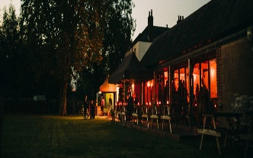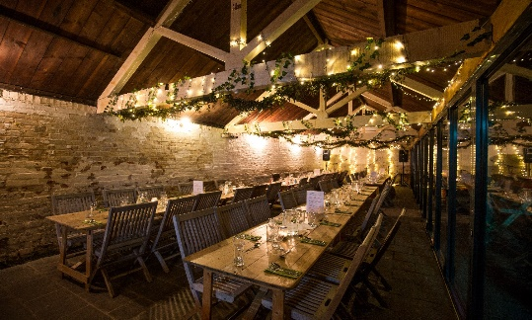  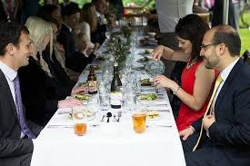 |  | 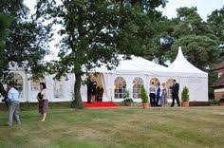  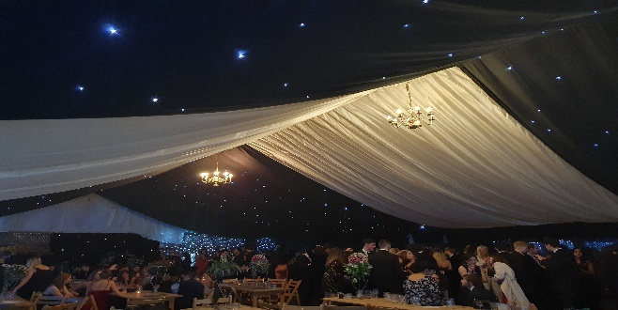  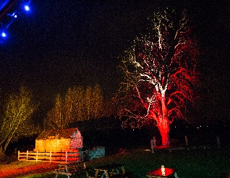 | 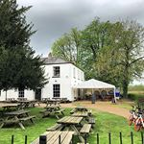  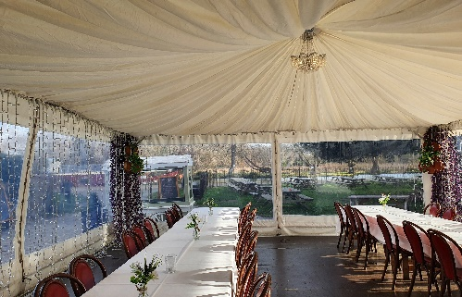  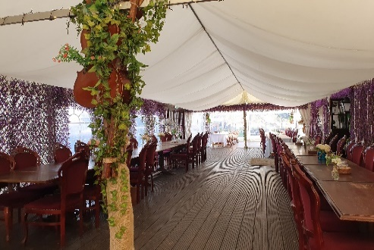 | 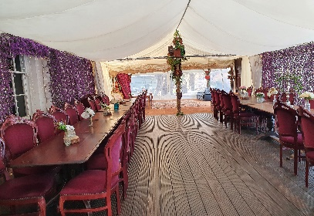  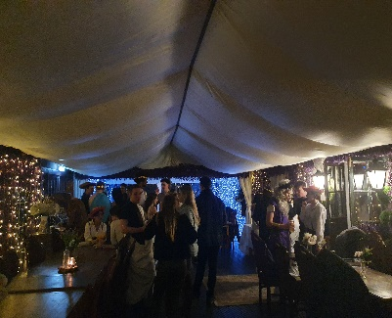  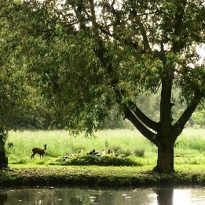 | 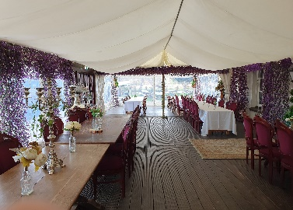  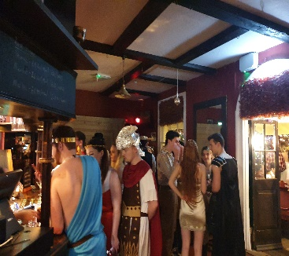  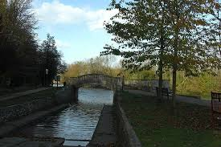
All prices are exclusive of VAT at 20%

Table linen can be hired by our linen company for £6 per cloth and linen napkins at 50p per napkin. Table & Venue Decoration. If required, you are welcome to bring your own decorations or use our decorations complimentary. Corkage: We do not offer corkage but have an extensive wine list to suit all budgets. Self-Catering: We are unable to offer this service due to access restrictions for outside caterers. Discretionary service charge of 7.5% of the total bill will be added to the final bill which will be shared between the front of house and kitchen team servicing your event.
Mon to Thu  9am to 5pm  6pm to 11pm  9am to 11pm | Meadowside Barn (supplement of £125 for the private terrace with stretch tent)  £250  £400  £500 | Meadowside Marquee  £500  £550  £650 | Riverside Marquee & Georgian  Music Room  £400  £500  £650 | Riverside Courtyard Marquee  £250  £300  £375 | Riverside Pagoda  £250  £300  £450
Friday  9am to 5pm  6pm to 12.30am  9am to 12.30am | £400  £550  £750 | £600  £750  £950 | £650  £850  £1150 | £350  £450  £700 | £450  £550  £800
Saturday  9am to 5pm  6pm to 12.30am  9am to 12.30am | £600  £650  £800 | £700  £800  £950 | £900  £1000  £1250 | £500  £550  £650 | £550  £650  £750
Sun 9am to 6pm  6pm to 11pm  9am to 11pm | £500  £500  £650 | £700  £700  £800 | £650  £850  £1150 | £300  £400  £700 | £450  £500  £650
Hire of garden games  Aunt Sally, Crazy Croquet, Giant Jenga, Boules. | Games Package  £75 | Games Package  £75 | Games Package  £75 | Games Package  £75 | Games Package  £75
De-luxe Garden Games Package to inc. the above +  8 x Adult & children sumo wrestling suits and mats.  Tug of war, Football + goal net. Full-size pool table  Badminton table, Basketball & hoop, Tiny-tots fun corner. | £145 | £145 | £145 | £145 | £145
Live Band to play Jazz/Swing/Popular/Irish etc £350 to £750 Ask for details | Price on Request | Price on Request | Price on Request | Price on Request | Price on Request
Hire of full PA system, speakers, mixing desk, bass amp & drum kit | Included | Not available  (need to add barn if you require amplified music) | Included | Not available | Not available
Hire of amplified speaker & mike for marquee to play low music/speeches | Included | £30 | £30 | Please ask for details | Please ask for details
Hire of Silent 3 channel LED silent disco headphones | £2 per headphone | £2 per headphone | £2 per headphone | £2 per headphone | £2 per headphone
Photobooth hire | £375 | £375 | £375 | £375 | £375
Hire of Firepit, logs, seating, | £75 | £75 | £75 | £75 | £75
Hire and set up of 86”TV | £35 | £35 | £35 | £35 | £35

Event Dining Options
For groups of up to 40 guests we can serve the Riverside Garden Menu which has starters, mains, desserts and specials.
(We can adapt menus to provide vegetarian or vegan only selection). We are able to provide many of the dish es gluten free, please ask for details.
Canapés £2.75 each
We serve a mixed selection of the following & recommend allowing for approximately three to four per person.
- Mandarin & Prune with Smoked Duck on White Bread.  - Trout Roe, Smoked Trout & Cucumber on Black Bread.  - Ham & Fig Butter on Olive Bread.  - Prawn, Basil-flavoured Cheese & Tomato Mini Brioche.  - Smoked Salmon, Lemon, Cheese & Cucumber Mini Brioche. | Vegetarian  - Aubergine, Ewe’s Cheese & Almonds on toast with Fig & Hazelnuts.  - Horseradish Cheese and Paprika on Farmhouse Bread with Spinach.  - Choux Pastry with Goat’s Cheese, Almonds and Pistachios.  - Fromage Frais with Piquilloes Peppers, Black Olive & curry on toast.  - Tomato and Basil Cheese, Grilled Vegetables on Walnut Bread.  - Mini Brioche with Brie Cheese Cream, Apple, Fig and Hazelnut. | Vegan  - Courgette Shortbread and Cucumber Hummus  - Mini Carrot, lemon, and ginger tart.  - Mint Pea Muffins with Almond Cream and Edamame Bean  - Mini Tomato Tarts with Piquillos and Peppers  - Walnut Crackers with Avocado and Almond  - Falafel mini bites  - Polenta Curry, Olive, and Cherry Tomato
Meadowside 3 course Feast £47.50
Served to the table either feasting style or plated. (50% reduction for children under 12).
Starter  All starters can be served gluten free.  Please select one or two options.  - Sweet Potato, Coconut & Chilli Soup with croutons (Vegan)  - Scottish smoked salmon, fennel & dill, mixed leaf.  - Wild Game terrine, piccalilli, mixed leaf.  - Smoked duck breast, fig compote, mixed leaf.  - Aubergine, Courgette & mixed pepper terrine, lemon dressing, mixed leaf. (Vegetarian)  - Beetroot falafel balls, spicy Yoghurt, mixed leaf. (Vegan) | Mains  All served with parsley new potatoes and seasonal fresh vegetables Please select two options  - Free-range poussin, grilled baby gem, tarragon, chermoula mayonnaise. (GF)  - Honey-glazed confit duck leg, red cabbage & apple slaw, plum coulis. (GF)  - Slow-cooked whole blade of beef, roasted shallots, red wine gravy. (GF) (+£3)  - Lamb shank, spring onion, mint, and anchovy salsa. (GF) (+£3)  - Pan-fried salmon, baby leeks, capers, lemon & dill pesto. (GF) (+£3)  - Honey-glazed pork belly, red cabbage & apple slaw, red pepper coulis. (GF)  - Whole trout, laksa sauce, cashew nuts, coriander. (GF)  - Prawn laksa, cashew nuts, Asian slaw. (GF)  - Marinated aubergine, pickled baby carrots & chillies, curry sauce. (Vegan) GF  - Roasted cauliflower, ras el hanout, tahini & lime sauce. (Vegan) (GF)  - Roast vegetable wellington, red wine gravy. (Vegan)  - Baby Leeks, preserved tomatoes, watercress, truffle vinaigrette (Vegan) GF | Dessert  All desserts are vegan & gluten free  Please select one option  - Light chocolate orange torte with toffee sauce.  - Raspberry frangipane with fruit coulis.  - Coconut & Rich chocolate tart, coconut cream,  - Blackcurrant and fresh fruit torte.  - Truffle brownie pudding.  - Rhubarb, ginger & chocolate ganache.  Twining’s Tea or Ground  Coffee £2.75pp

Riverside Buffet Menus
Four menu options; starters and desserts are served to the table and the main course served buffet style. Two courses £29.50 per person Three courses £35 Please select from the following: -
 | Starter  All starters are gluten free. Please select one or two options  - Chicken, Apricot & Pancetta Terrine, with a rocket and cherry tomato salad.  - Goat’s cheese, beetroot, pickled walnut, mixed leaf. (Vegetarian)  - White bean hummus, crudites, mixed leaf. (Vegan).  - Smoked mackerel, beetroot & horseradish relish, mixed leaf.  - Meat free koftas, spicy Yoghurt, mixed leaf. (Vegan)  - Chargrilled vegetable terrine, lemon dressing, mixed leaf. (Vegetarian) |  | Dessert  All desserts are vegan and gluten free. Please select one option  - Black Forest and dark chocolate pudding.  - Chocolate Brownie cheesecake  - Lemon Tart with raspberry coulis  - Raspberry & Dark chocolate torte.  - Burnt toffee brownie dessert  - Chocolate orange dessert  Twining’s Tea or Ground Coffee £2.75pp (inc.VAT)
Banquet Barbeque  Served with a selection of salads, sauces and buns.  (We can offer a total vegetarian or Vegan BBQ on request)  BBQ includes the following: -  - Prime angus beef burgers.  - Chipolata pork sausages  - Vegan Burgers.  - Chicken breast skewers.  - Plant based Sausages.  Please select three salads from below: -  - Caesar salad.  - Roasted vegetable salad. (Vegan)  - Potato salad. (Vegan)  - Chicory, blue cheese, pear & walnut. (Vegetarian)  - Garden leaf & soft herb, house dressing. (Vegan).  - Heirloom tomato, red onion, olive oil & balsamic. (Vegan)  - Greek salad. (Vegetarian) |  | Riverside Feast  All served with seasonal fresh vegetables, rice, fresh green salad and  Parsley and garlic new potatoes.  (Please select up to three of the following dishes).  - Slowly cooked Boeuf Bourguignon. (+£2.50) (GF)  - Slow cooked cider & mustard pork shoulder. (GF)  - Grilled Aubergine & Chickpea Tagine, roasted almonds (Vegan) (GF)  - Rosemary, lemon & honey chicken. (GF)  - Grilled Salmon Fillet, lemon dill and butter sauce (+£2.50)  - Lamb shank in Oxford porter, mint and spring onion salsa.. (+£2.50) (GF)  - Riverside green lentil & courgette chilli finished with lime & coriander. (Vegan) (GF)  - Portobello mushrooms, vine tomatoes, watercress, truffle vinaigrette. (Vegan) (GF) |  | Traditional Hog Roast  Served with a selection of salads, plus sauces, and buns.  12-hour Slow Roasted Pig  Plus  BBQ pulled jackfruit, Slow-cooked in a smoky BBQ sauce. (Vegan)  or  Riverside green lentil & courgette chilli finished with lime & coriander. (Vegan) (GF)  Please select three salads from below:-  - Caesar salad.  - Roasted vegetable salad. (Vegan)  - Potato salad. (Vegan)  - Chicory, blue cheese, pear & walnut. (Vegetarian)  - Garden leaf & soft herb, house dressing. (Vegan).  - Heirloom tomato, red onion, olive oil & balsamic. (Vegan)  - Greek salad. (Vegetarian)
Banquet Cold Buffet
Cold buffet includes the following: -  - Cheese board selection with crackers grapes and pickles. Honey mustard glazed gammon. Red Thai chicken skewers.  - Butchers’ pork pies. Smoked salmon, Farmhouse sausage rolls. Baked Cheese & Broccoli Quiche. Mini Chocolate Eclairs.  Vegan selection:  - Moroccan bean lattice-topped puff pastry roll. Selection of Samosas, Sweet potato curry pastry, Cornish sausage rolls. Sweet Potato Falafel. Farmhouse bread. Vegan Brownies. | Please choose three of the salads below:-  - Caesar salad. Potato salad. (Vegan)  - Roasted vegetable salad. (Vegan)  - Chicory, blue cheese, pear & walnut. (Vegetarian)  - Garden leaf & soft herb, house dressing. (Vegan).  - Heirloom tomato, red onion, olive oil & balsamic. (Vegan).  - Greek salad. (Vegetarian).

Children’s Menu
Smaller size portion of selected menu; 50% reduction or we can offer the following menu: -
Starters  Farmhouse garden vegetable soup with herb & black pepper croutons. (vegan). |  | Mains  Angus beefburger or vegan burger with lettuce, tomato and topped with cheese with triple cooked chips and an option of a gluten free bap.  Or: Cod or vegan fish fingers and chips with garden peas (GF) |  | Dessert  Callestick Farm ice cream  (Vanilla, Chocolate or Strawberry)  Vegan options available.
Evening Nibbles
Isis River Cheese Tower £9.50pp (min 60 persons)
A stunning tower feast of the finest cheeses from Oxford’s famous specialist cheesemonger. The selection includes local favourites Oxford Blue and “Oxford Isis” named after the Isis River and is accompanied by chutney, grapes, crudités, pickled onions, crackers. (Vegan cheese can be included on request).

We can add all of the following buffet items (supplement £4.50 pp)
Butchers oversized pork pies, mustard. Potato salad. Pork cocktail sausages with ketchup dip. Vegan sausage rolls. Vegan sweet potato falafel. Fresh mixed leaf Salad. Moroccan bean lattice-topped vegan pastry roll. Farmhouse Coleslaw. Farmhouse bread.

Street Food Selection  £13.50 per person.  (Please select 1 or 2 dishes from the options below)  - Pizza Slab Feast: Stone-baked Pizzas served in large slabs: Margherita (Vegetarian) Roasted Tomato and basil (Vegan) GF, Pepperoni served with a Farmhouse mixed leaf salad or spicy wedges.  - Moroccan Vegetable Tagine served with cous cous. (Vegan)  - Coconut Chicken – Caribbean style curried chicken seasoned with thyme, garlic, ginger and served with rice.  - Pulled pork pig on a bap: from our own hog roast with apple sauce, caramelised onions, coleslaw and pork stuffing, served with spicy wedges.  - Irish Lamb and Pearl Barley Hot Pot served with soda bread.  - Smoked Pork and Pancetta Cider Stew braised in local cider with root vegetables and fennel served with warm bread.  - Curried Coconut Sweet Potato’ Farmhouse recipe with a blend of Caribbean herbs & spices served with herby rice. (Vegan)  - BBQ Pulled Jackfruit, Slow & low jackfruit cooked in a smoky BBQ sauce and served with spicy wedges, (Vegan)  - Spiced Pepper & Three Bean Chilli served with rice. (Vegan) |  |  |  |  | Any of the following salads can be added at a supplement of £2.50 pp  - Caesar salad.  - Potato salad. (Vegan)  - Roasted vegetable salad. (Vegan)  - Chicory, blue cheese, pear & walnut. (Vegetarian)  - Heirloom tomato, red onion, olive oil & balsamic. (Vegan).  - Greek salad. (Vegetarian).
Arrival Drink and Canape Package £10pp plus VAT

Enjoy a glass of Prosecco plus a selection of canapes (3 per person)
Freshly baked sausage rolls, Warm Vegetable Samosas (Vegan), Mini Margherita Pizzas (Vegetarian).Warm Vegan Sausage rolls, Chicken satay skewers, Mini Vegetable Spring Rolls (Vegan)
(Gluten Free options available)

Hot Chocolate and Marshmallows £4.50pp
Choose a hot chocolate with a skewer of marshmallows to toast over the firepit or add marshmallows/spiced rum/brandy/baileys for that special touch

Wine/Beer/Spirits Menu available on request.
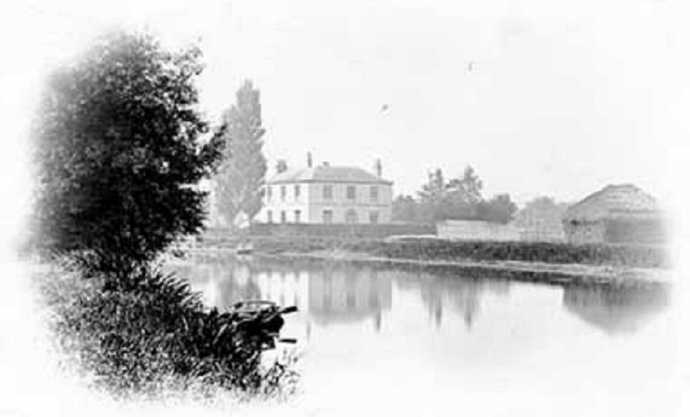

EVENT BOOKING FEES & CANCELLATIONS
.
To confirm a booking, the venue hire fee will be invoiced and funds held on account.
At the time of confirmation, you will be provided with an approximate quotation for the total cost of your event
The final invoice will be sent the day after the event and payment terms is 7 days from receipt of this invoice. We can issue the invoice before the event if you prefer.

All prices above are exclusive of VAT.

Cancellations

Up to six months (26 weeks) before the event: you will be entitled to cancel with a full refund or to re-arrange to an available date.
Only one re-arranged date will apply so should a further request to cancel a re-arranged date be made, the deposit will not be returnable and there will not be an option to re-arrange the date.

Up to 3 months (12 weeks) before the event: refunds will not apply for deposits however you will be entitled to re-arrange the date and transfer any paid funds to the new date.
Only one re-arranged date will apply, so should a further request to cancel a re-arranged date be made, there will not be an option to re-arrange the date.

12 weeks or less before the event, the deposit will be non-returnable and a change of date will not be available.

Any Covid-related cancellation due to government restrictions will qualify for a complete re-fund regardless of when the event would have taken place.

